**Unit 1 | Assignment - KickStart**

1. What are three conclusions we can make about Kickstarter campaigns given the provided data?

* A Kickstarter project is a crowdfunded project where a project or venture raise money from people on-line by selling the product based on their concept or idea and before they are manufactured or designed.

Our data of Kickstarter project tells us a story behind its creation. The following are the main factors which governs the Kickstarter Campaign:

* + Set a project and description for each project and Category and sub Category it belongs to.
  + Set a minimum funding goal.
  + Set a Start Date and Deadline
  + If a Kickstarter project is unable to collect minimum goal, the project will be declared failed and will not receive the fund.

The three conclusions after understanding the data background and then analyzing it via 3 Piviot table we made and other graphs we come to following conclusions

1. Out of 14 categories (Art, Comics, Dance, Design, Fashion, Film & Video, Film & amp; Video, Food, Games, Music, Photography, Publishing, Technology, Theater) and 51 sub categories.
   1. **53.11%** of campaigns was successful (Fig 1)
   2. **37.19%** of campaigns failed (Fig 1)
   3. **8.48%** of campaigns was canceled (Fig 1)
   4. **1.22%** of campaigns was Live (Fig 1)
   5. Lesser the goal amounts the better the Success Rate. (Fig 2, Fig 8)

***Fig 1***

***Fig 2***

1. Out of all successful projects, the following are the categories’ performance:
2. Music is the best, (Fig 3 & Fig 4)
3. Game is the Median (Fig 3 & Fig 4)
4. Journalism is the worst (Fig 3 & Fig 4)
5. Note: All projects of Journalism were canceled (Fig 3 & Fig 4)
6. Theater has the largest number of projects (Fig 5)
   1. Total Projects filed under Theater category: 1393
   2. Successful Projects under Theater category: 839

***Fig 3***

|  |  |  |
| --- | --- | --- |
| Music | 77% | BEST |
| Theater | 60% |  |
| Film & video | 58% |  |
| Photography | 47% |  |
| Games | 36% | MEDIAN |
| Technology | 35% |  |
| Publishing | 34% |  |
| Food | 17% |  |
| Journalism | 0% | WORST |
| **Successful** | **53.11%** |  |
| **Canceled** | **8.48%** |  |
| **Live** | **1.22%** |  |
| **Failed** | **37.19%** |  |

***Fig 4***

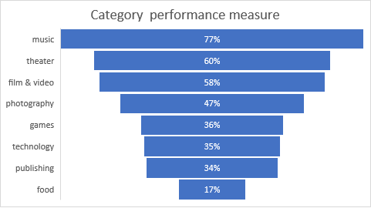

***Fig 5***

1. Out of all projects, on Sub Categories Plays has the largest number of projects (Fig 6)
   1. Total Projects filed under Plays Sub Category: 1066
   2. Successful Projects under Plays Sub Category: 694

***Fig 6***

1. What are some of the limitations of this dataset?

* Some of the limitations of this dataset are as follows:

1. Its Analysis is not Qualitative data, just Quantitative data because of the following reasons:
   * 1. Limited description of Project’s product and no sentiments can be captured out of it.
     2. No knowledge of the profile or credibility report on the entrepreneur.
     3. Limited knowledge of the Audience.
     4. Limited knowledge of cause of success, failure, and cancellation
     5. Limited knowledge of relationship.
2. Its limited to certain countries only (limited Audience)
3. What are some other possible tables/graphs that we could create?
   * 1. Pie Chart (Fig 1) measuring
        + canceled
        + failed
        + live
        + successful
     2. Funnel Chart measuring Category Performance % (Fig 4)
     3. Clustered column graph based on number of successful projects vs Category based on Years. (Fig 7)

***Fig 7***

* + 1. Clustered Column Chart (Fig 8)

***Fig 8***